RAJALAKSHMI ENGINEERING COLLEGE
An Autonomous Institution, Affiliated to Anna University
Rajalakshmi Nagar, Thandalam – 602 105

WEB TECHNOLOGY AND MOBILE APPLICATION
Experiment – 01
2025-26

By
NIJANTHAN V
B-TECH AI&DS
2116241801185

Expt .NO: 01 DATE:
Web Page Creation using HTML
AIM:
To create a web page that embeds a map with hotspots, frames, and links. The web page should be designed using HTML, incorporating embedded, external, and inline CSS for styling. This exercise aims to enhance understanding of integrating multimedia elements like maps, creating interactive hotspots, and organizing content using frames while applying different CSS techniques for styling.
ALGORITHM:
Create the HTML structure:
- Set up the basic HTML document with <!DOCTYPE html>, <html>, <head>, and <body> tags.
- In the <head>, link the external CSS file (<link> tag), define the title, and include any metadata.
- In the <body>, create the necessary elements:
  - Frames: Use the <frameset> tag to create a frame layout (for older browsers, use <iframe> instead).
  - Map: Use the <img> tag to display a map.
  - Hotspots: Create clickable regions using the <map> and <area> tags.
  - Links: Add hyperlinks (<a>) to navigate to different parts of the page or external sites.

Create CSS Styles:
- External CSS: In a separate file, define styles such as colors, fonts, and layout for the entire page.
- Inline CSS: Use the style attribute within specific tags to apply styles (e.g., in <div> or <p> tags).
- Embedded CSS: Inside the <style> tag in the <head>, define styles for specific elements like the map, frames, and text.
Map with Hotspots:
- Use the <map> tag to create an image map.
- Define the <area> tag for each hotspot, specifying the coordinates (e.g., coords="x,y,x2,y2") for clickable areas on the map.
Frames:
- Use the <iframe> tag for embedding external content like a map or another webpage, with attributes such as src for the URL, width, and height.
Add Links:
- Inside the <body>, use the <a> tag to create links for navigation (for example, to link to specific parts of the page or external sites).
Test the Page:
- Test the webpage to check the functionality of frames, hotspots, and links. Ensure that the map hotspots are clickable and the linked content displays correctly.
- Ensure that the styles are applied properly using inline, embedded, and external CSS.

CODE:

HTML Code:

<!DOCTYPE html>
<html lang="en">
<head>
<meta charset="UTF-8">
<meta name="viewport" content="width=device-width, initial-scale=1.0">
<link rel="stylesheet" href="https://cdnjs.cloudflare.com/ajax/libs/font-awesome/6.5.0/css/all.min.css">
<link rel="stylesheet" href="MOB.css">
<title>MOB Pay</title>
<style>
*{
font-family: 'Times New Roman', Times, serif;
}
body {
margin: 0;
background-color:rgb(230, 135, 10);
color: #333;
}
header {
padding: 25px;
background-color:burlywood;
color: rgb(8, 8, 8);
width: auto;
position: sticky;
top: 0px;
}
nav {
display: flex;
justify-content: space-between;
align-items: center;
}

nav h1 {
margin: 10px;
}

nav ul {
list-style: none;
display: flex;
gap: 1rem;
margin: 0;
padding: 0;
}

nav ul li {
display: inline;
}

.search {
display: flex;
justify-content: center;
margin: 2rem 0;
}

#search {
width: 60%;
padding: 0.7rem;
border-radius: 25px;
border: 1px solid #ccc;
font-size: 1rem;
box-shadow: 0 0 5px black;
}

/* Main container for first row of cards */
#mainTable {
display: flex;
flex-wrap: wrap;
justify-content: center;
gap: 20px; /* spacing between cards */
margin: 2rem auto;
max-width: 1200px;
padding: 0 1rem;

}

/* Cards inside mainTable */
#card {
flex: 1 1 300px; /* flexible width, min 300px */
max-width: 400px;
background-color: rgb(255, 250, 250);
padding: 15px;
border-radius: 10px;
box-shadow: 0 0 5px black;
text-align: center;
height: auto;
}

/* Second row card */
#card1 {
flex: 1 1 100%; /* full width row */
max-width: 400px;
background-color: rgb(255, 250, 250);
padding: 15px;
border-radius: 10px;
box-shadow: 0 0 5px black;
text-align: center;
margin: 2rem auto; /* spacing from first row */
display: flex;
flex-wrap:;
flex-direction: column;
gap: 20px;
}

/* Responsive adjustments */
@media (max-width: 1024px) {
#mainTable {
justify-content: space-around;
}
}

@media (max-width: 768px) {
#card {
flex: 1 1 100%; /* stack cards on tablets */
max-width: 100%;
}

#card1 {
max-width: 100%; /* full width on tablets */
}
}

@media (max-width: 480px) {
#card, #card1 {
padding: 10px;
font-size: 0.9rem;
}

#mainTable {
gap: 15px;
}
}

#card img, #card1 img {
border-radius: 10px;
width: 100%;
height: auto;
}

iframe {
border: none;
border-radius: 10px;
}

h1 {
font-size: 1.5rem;
margin-bottom: 1rem;
}

</style>
</head>
<body>
<header>
<nav>
<h1>MOB Pay</h1>
<ul>
<li><button>Contact</button></li>
<li><button>Services</button></li>
<li><button type="button" onclick="window.location.href='MOB_login.HTML'">Login</button></li>
</ul>
</nav>
</header>

<div class="search">
<input type="search" id="search" placeholder=" 🔎︎ Search">
</div>
<section id="mainTable">
<div id="card">
<h1 style="color:rgb(128, 6, 132);">Credit card Bill Payment</h1><br><br>
<img src="C:\Users\niran\OneDrive\Desktop\MOB Pay\Credit card.avif" alt="Life Insurance">
<br><br>
<h3 style=" text-align: center;"> Credit card bill payment has now become easier with Axis Bank.
Enjoy safe & secure methods like mobile banking, internet banking, etc. Pay Credit Card Bills</h3>
</div>

<div id="card">
<h1>Wiki Website</h1>
<iframe src="https://en.wikipedia.org/wiki/Online_banking" width="400" height="400" title="Online Banking Wiki"></iframe>
</div>

<div id="card">
<h1>Savings through MOB Pay</h1>
<a href="http://wikipedia.com/wiki/html">
<img src="C:\Users\niran\OneDrive\Desktop\MOB Pay\Piggy bank.webp" alt="Piggy Bank Savings">
</a>
</div>
</section>

<!-- Footer Section -->
<footer>
<div class="footer-container">
<!-- Social Media Icons -->
<div class="social-icons">
<a href="https://facebook.com" target="_blank"><i class="fab fa-facebook-f"></i></a>
<a href="https://wa.me/1234567890" target="_blank"><i class="fab fa-whatsapp"></i></a>
<a href="https://instagram.com" target="_blank"><i class="fab fa-instagram"></i></a>
<a href="https://youtube.com" target="_blank"><i class="fab fa-youtube"></i></a>
<a href="https://linkedin.com" target="_blank"><i class="fab fa-linkedin-in"></i></a>
</div>

<p style="font-size:xxx-large;font-family:'Times New Roman', Times, serif;">MOB Pay</p>

<!-- Contact Details -->
<div class="contact-info">
<h1><strong>Contact Us</strong></h1>
<h3>Email: <a href="mailto:Niranjan.v.2024.aiml@rajalakshmi.edu.in">Niranjan.v.2024.aiml@rajalakshmi.edu.in</a></h3>
<h3>Phone: <a href="tel: +91 8248252513">+91 82482 52513</a></h3>
<h3>Address: No:41,Housing Board,Kanchipuram, Tamil Nadu, India</h3>
</div>
</div>
<hr style="width:500px;height:2px;">
<!-- Footer Bottom -->
<div class="footer-bottom">
<h3>Copyright&copy; MOB Pay. All rights reserved.</h3>
</div>
</footer>
</body>
</html>

CSS code:

footer {
background-color:burlywood;
color: black;
padding: 30px 20px;
text-align: center;
}
.footer-container {
display: flex;
flex-direction: column;
align-items: center;
gap: 20px;
}
.social-icons {
display: flex;
gap: 15px;
}
.social-icons a {
color: black;
font-size: 22px;
transition: color 0.3s ease;
}
.social-icons a:hover {
color: #1da1f2; /* highlight color on hover */
}
.contact-info {
font-size: 15px;
line-height: 1.6;
}
.contact-info a {
color:black;
text-decoration: none;
}
.contact-info a:hover {
text-decoration: underline;
}
.footer-bottom {
margin-top: 15px;
font-size: 13px;
color: black;
}
@media (min-width: 600px) {
.footer-container {
flex-direction: row;
justify-content: space-between;
align-items: flex-start;
text-align: left;
}
}

OUTPUT:

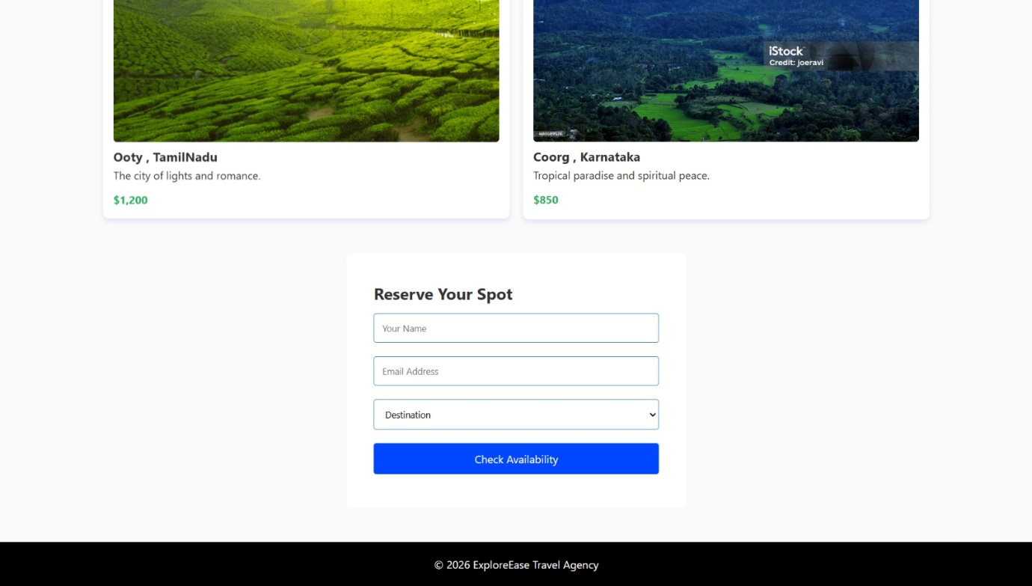
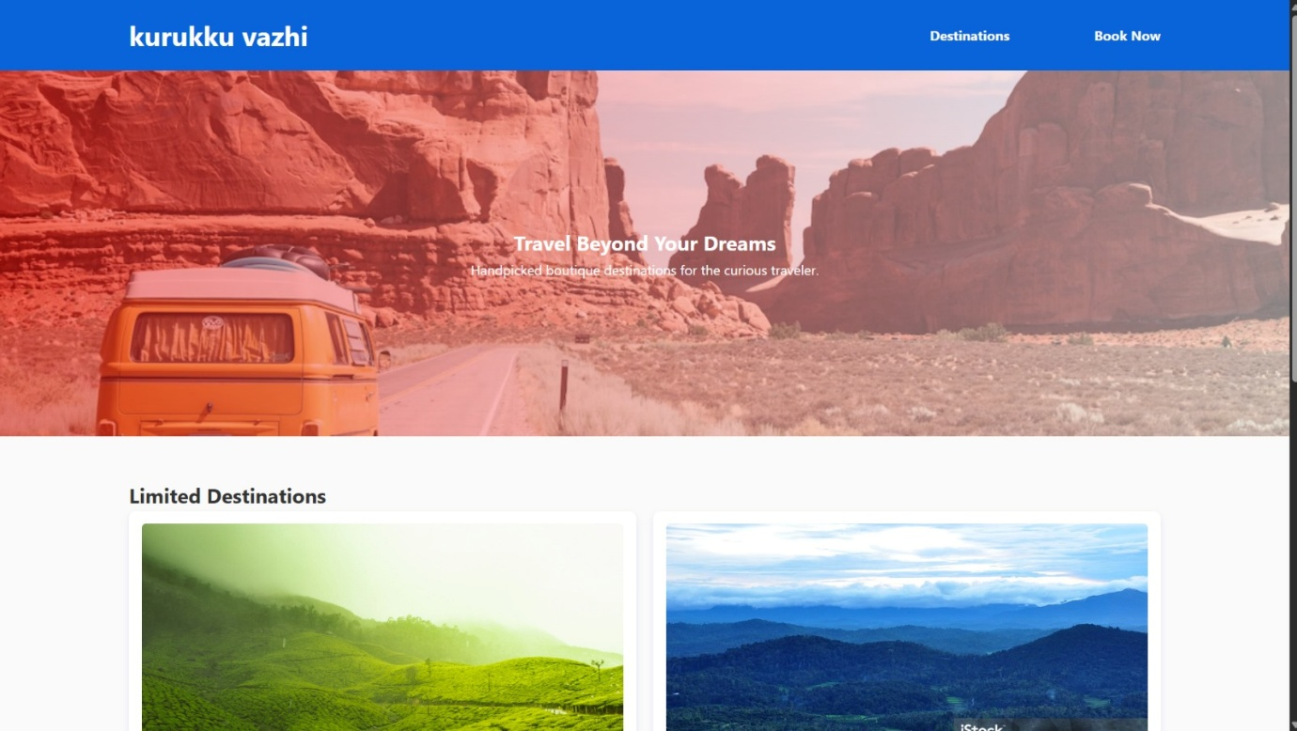

RESULT:
Html Page is created with embedded Chennai map along with hot spot, frames & links.

